
OPC Unified Architecture
Specification
Part 2: Security Model
Release Candidate 1.01.52
March 6, 2008

Specification Type | Industry Standard Specification
Title: | OPC Unified Architecture  Security Model | Date: | March 6, 2008
Version: | Release Candidate 1.01.52 | Software | MS-Word
 |  | Source: | 0000.doc
Author: | OPC Foundation | Status: | Release Candidate

CONTENTS
Page

FOREWORD vii
AGREEMENT OF USE vii
1 Scope 1
2 Reference documents 1
2.1 References 1
3 Terms, definitions, and abbreviations 2
3.1 OPC UA Part 1 terms 2
3.2 OPC UA Security terms 3
3.2.1 Application Instance 3
3.2.2 Application Instance Certificate 3
3.2.3 Asymmetric Cryptography 3
3.2.4 Asymmetric Encryption 3
3.2.5 Asymmetric Signature 3
3.2.6 Auditability 3
3.2.7 Auditing 4
3.2.8 Authentication 4
3.2.9 Authorization 4
3.2.10 Availability 4
3.2.11 Confidentiality 4
3.2.12 Cryptogrophy 4
3.2.13 Cyber Security Management System (CSMS) 4
3.2.14 Digital Certificate 4
3.2.15 Digital Signature 4
3.2.16 Hash Function 4
3.2.17 Hashed Message Authentication Code (HMAC) 4
3.2.18 Integrity 4
3.2.19 Key Exchange Algorithm 5
3.2.20 Message Authentication Code (MAC) 5
3.2.21 Message Signature 5
3.2.22 Non-Repudiation 5
3.2.23 Nonce 5
3.2.24 OPC UA Application 5
3.2.25 Private Key 5
3.2.26 Public Key 5
3.2.27 Public Key Infrastructure (PKI) 5
3.2.28 Rivest-Shamir-Adleman (RSA) 6
3.2.29 Secure Channel 6
3.2.30 Symmetric Cryptography 6
3.2.31 Symmetric Encryption 6
3.2.32 Symmetric Signature 6
3.2.33 X.509 Certificate 6
3.3 Abbreviations and symbols 6
3.4 Conventions 7
3.4.1 Conventions for security model figures 7
4 OPC UA Security architecture 7
4.1 OPC UA Security Environment 7
4.2 Security Objectives 8
4.2.1 Overview 8
4.2.2 Authentication 8
4.2.3 Authorization 9
4.2.4 Confidentiality 9
4.2.5 Integrity 9
4.2.6 Auditability 9
4.2.7 Availability 9
4.3 Security Threats to OPC UA Systems 9
4.3.1 Overview 9
4.3.2 Message Flooding 9
4.3.3 Eavesdropping 10
4.3.4 Message Spoofing 10
4.3.5 Message Alteration 10
4.3.6 Message Replay 10
4.3.7 Malformed Messages 10
4.3.8 Server Profiling 11
4.3.9 Session Hijacking 11
4.3.10 Rogue Server 11
4.3.11 Compromising User Credentials 11
4.4 OPC UA Relationship to Site Security 12
4.5 OPC UA Security Architecture 13
4.6 Security Policies 14
4.7 Security Profiles 15
4.8 User Authorization 15
4.9 User Authentication 15
4.10 Application Authentication 15
4.11 OPC UA Security Related Services 15
4.12 Auditing 16
4.12.1 General 16
4.12.2 Single client and server 17
4.12.3 Aggregating server 18
4.12.4 Aggregation through a non-auditing server 19
4.12.5 Aggregating server with service distribution 20
5 Security Reconciliation 21
5.1 Reconciliation of Threats with OPC UA Security Mechanisms 21
5.1.1 Overview 21
5.1.2 Message Flooding 21
5.1.3 Eavesdropping 21
5.1.4 Message Spoofing 22
5.1.5 Message Alteration 22
5.1.6 Message Replay 22
5.1.7 Malformed Messages 22
5.1.8 Server Profiling 22
5.1.9 Session Hijacking 22
5.1.10 Rogue Server 22
5.1.11 Compromising User Credentials 23
5.2 Reconciliation of Objectives with OPC UA Security Mechanisms 23
5.2.1 Overview 23
5.2.2 Authentication 23
5.2.3 Authorization 23
5.2.4 Confidentiality 23
5.2.5 Integrity 24
5.2.6 Auditability 24
5.2.7 Availability 24
6 Implementation considerations 24
6.1 Appropriate Timeouts: 24
6.2 Strict Message Processing 25
6.3 Random Number Generation 25
6.4 Special and Reserved Packets 25
6.5 Rate Limiting and Flow Control 25

Figures
Figure 1 - OPC UA Network Model 8
Figure 2 – OPC UA Security Architecture 13
Figure 3 – Simple Servers 17
Figure 4 – Aggregating Servers 18
Figure 5 – Aggregation with a Non-Auditing Server 19
Figure 6 – Aggregate server with Service Distribution 20

OPC Foundation
____________

UNIFIED ARCHITECTURE –
FOREWORD
This specification is the specification for developers of OPC UA Applications. The specification is a result of an analysis and design process to develop a standard interface to facilitate the development of applications by multiple vendors that shall inter-operate seamlessly together.
Copyright © 2006-2008, OPC Foundation, Inc.
AGREEMENT OF USE
COPYRIGHT RESTRICTIONS
Any unauthorized use of this specification may violate copyright laws, trademark laws, and communications regulations and statutes. This document contains information which is protected by copyright. All Rights Reserved. No part of this work covered by copyright herein may be reproduced or used in any form or by any means--graphic, electronic, or mechanical, including photocopying, recording, taping, or information storage and retrieval systems--without permission of the copyright owner.
OPC Foundation members and non-members are prohibited from copying and redistributing this specification. All copies must be obtained on an individual basis, directly from the OPC Foundation Web site
http://www.opcfoundation.org.
PATENTS
The attention of adopters is directed to the possibility that compliance with or adoption of OPC specifications may require use of an invention covered by patent rights. OPC shall not be responsible for identifying patents for which a license may be required by any OPC specification, or for conducting legal inquiries into the legal validity or scope of those patents that are brought to its attention. OPC specifications are prospective and advisory only. Prospective users are responsible for protecting themselves against liability for infringement of patents.
WARRANTY AND LIABILITY DISCLAIMERS
WHILE THIS PUBLICATION IS BELIEVED TO BE ACCURATE, IT IS PROVIDED "AS IS" AND MAY CONTAIN ERRORS OR MISPRINTS. THE OPC FOUDATION MAKES NO WARRANTY OF ANY KIND, EXPRESSED OR IMPLIED, WITH REGARD TO THIS PUBLICATION, INCLUDING BUT NOT LIMITED TO ANY WARRANTY OF TITLE OR OWNERSHIP, IMPLIED WARRANTY OF MERCHANTABILITY OR WARRANTY OF FITNESS FOR A PARTICULAR PURPOSE OR USE. IN NO EVENT SHALL THE OPC FOUNDATION BE LIABLE FOR ERRORS CONTAINED HEREIN OR FOR DIRECT, INDIRECT, INCIDENTAL, SPECIAL, CONSEQUENTIAL, RELIANCE OR COVER DAMAGES, INCLUDING LOSS OF PROFITS, REVENUE, DATA OR USE, INCURRED BY ANY USER OR ANY THIRD PARTY IN CONNECTION WITH THE FURNISHING, PERFORMANCE, OR USE OF THIS MATERIAL, EVEN IF ADVISED OF THE POSSIBILITY OF SUCH DAMAGES.
The entire risk as to the quality and performance of software developed using this specification is borne by you.
RESTRICTED RIGHTS LEGEND
This Specification is provided with Restricted Rights. Use, duplication or disclosure by the U.S. government is subject to restrictions as set forth in (a) this Agreement pursuant to DFARs 227.7202-3(a); (b) subparagraph (c)(1)(i) of the Rights in Technical Data and Computer Software clause at DFARs 252.227-7013; or (c) the Commercial Computer Software Restricted Rights clause at FAR 52.227-19 subdivision (c)(1) and (2), as applicable. Contractor / manufacturer are the OPC Foundation,. 16101 N. 82nd Street, Suite 3B, Scottsdale, AZ, 85260-1830
COMPLIANCE
The OPC Foundation shall at all times be the sole entity that may authorize developers, suppliers and sellers of hardware and software to use certification marks, trademarks or other special designations to indicate compliance with these materials. Products developed using this specification may claim compliance or conformance with this specification if and only if the software satisfactorily meets the certification requirements set by the OPC Foundation. Products that do not meet these requirements may claim only that the product was based on this specification and must not claim compliance or conformance with this specification.
Trademarks
Most computer and software brand names have trademarks or registered trademarks. The individual trademarks have not been listed here.
GENERAL PROVISIONS
Should any provision of this Agreement be held to be void, invalid, unenforceable or illegal by a court, the validity and enforceability of the other provisions shall not be affected thereby.
This Agreement shall be governed by and construed under the laws of the State of Minnesota, excluding its choice or law rules.
This Agreement embodies the entire understanding between the parties with respect to, and supersedes any prior understanding or agreement (oral or written) relating to, this specification.
ISSUE REPORTING
The OPC Foundation strives to maintain the highest quality standards for its published specifications, hence they undergo constant review and refinement. Readers are encouraged to report any issues and view any existing errata here:
http://www.opcfoundation.org/errata

Scope
This specification describes the OPC Unified Architecture (OPC UA) security model. It describes the security threats of the physical, hardware, and software environments in which OPC UA is expected to run. It describes how OPC UA relies upon other standards for security. It gives an overview of the security features that are specified in other parts of the OPC UA specification. It references services, mappings, and profiles that are specified normatively in other parts of this multi-part specification. This part of the specification is informative rather than normative. Any seeming ambiguity between this part and one of the normative parts does not remove or reduce the requirement specified in the normative part.
This Part 2 is directed to readers who will develop OPC UA client or server applications or implement the OPC UA services layer.
It is assumed that the reader is familiar with Web Services and XML/SOAP. Information on these technologies can be found in SOAP Part 1: and SOAP Part 2.

Reference documents

References
Part 1: OPC UA Specification: Part 1 – Concepts
http://www.opcfoundation.org/UA/Part1/
Part 3: OPC UA Specification: Part 3 – Address Space Model
http://www.opcfoundation.org/UA/Part3/
Part 4: OPC UA Specification: Part 4 – Services
http://www.opcfoundation.org/UA/Part4/
Part 5:: OPC UA Specification: Part 5 – Information Model
http://www.opcfoundation.org/UA/Part5/
Part 6: OPC UA Specification: Part 6 – Mappings
http://www.opcfoundation.org/UA/Part6/
Part 7: OPC UA Specification: Part 7 – Profiles
http://www.opcfoundation.org/UA/Part7/
Part 12: OPC UA Specification: Part 12 – Discovery
http://www.opcfoundation.org/UA/Part12/
SOAP Part 1: SOAP Version 1.2 Part 1: Messaging Framework
http://www.w3.org/TR/soap12-part1/
SOAP Part 2: SOAP Version 1.2 Part 2: Adjuncts
http://www.w3.org/TR/soap12-part2/
XML Encryption: XML Encryption Syntax and Processing
http://www.w3.org/TR/xmlenc-core/
XML Signature:: XML-Signature Syntax and Processing
http://www.w3.org/TR/xmldsig-core/
WS Security: SOAP Message Security 1.1
http://www.oasis-open.org/committees/download.php/16790/wss-v1.1-spec-os-SOAPMessageSecurity.pdf
WS Addressing: Web Services Addressing (WS-Addressing)
http://www.w3.org/Submission/ws-addressing/
WS Trust: Web Services Trust Language (WS-Trust)
http://specs.xmlsoap.org/ws/2005/02/trust/WS-Trust.pdf
WS Secure Conversation: WebServices Secure Conversation Language (WS-SecureConversation)
http://specs.xmlsoap.org/ws/2005/02/sc/WS-SecureConversation.pdf
SSL/TLS: RFC 2246: The TLS Protocol Version 1.0
http://www.ietf.org/rfc/rfc2246.txt
:X509: X.509 Public Key Certificate Infrastructure
http://www.itu.int/rec/T-REC-X.509-200003-I/e
HTTP: RFC 2616: Hypertext Transfer Protocol - HTTP/1.1
http://www.ietf.org/rfc/rfc2616.txt
HTTPS: RFC 2818: HTTP Over TLS
http://www.ietf.org/rfc/rfc2818.txt
IS Glossary: Internet Security Glossary
http://www.ietf.org/rfc/rfc2828.txt
NIST 800-12: Introduction to Computer Security
http://csrc.nist.gov/publications/nistpubs/800-12/
NERC CIP: CIP 002-1 through CIP 009-1, by North-American Electric Reliability Council
http://www.nerc.com/~filez/standards/Cyber-Security-Permanent.html
IEC 62351: Data and Communications Security
http://www.iec.ch/heb/d_mdoc-e050507.htm
SPP-ICS: System Protection Profile – Industrial Control System, by Process Control Security Requirements Forum (PCSRF)
http://www.isd.mel.nist.gov/projects/processcontrol/SPP-ICSv1.0.pdf
SHA-1: Secure Hash Algorithm RFC
http://tools.ietf.org/html/rfc3174
PKI: Public Key Infrastructure article in Wikipedia
http://en.wikipedia.org/wiki/Public_key_infrastructure
X509 PKI: Internet X.509 Public Key Infrastructure
http://www.ietf.org/rfc/rfc3280.txt

Terms, definitions, and abbreviations

OPC UA Part 1 terms
The following terms defined in Part 1 apply.
- certificate
- command
- event
- message
- notification
- profile
- subscription

OPC UA Security terms

Application Instance
an individual installation of a program running on one computer.
NOTE: There can be several Application Instances of the same application running at the same time on several computers or possibly the same computer.

Application Instance Certificate
a Digital Certificate of an individual instance of an application that has been installed in an individual host.
NOTE: Different installations of one software product would have different Application Instance Certificates.

Asymmetric Cryptography
a Cryptography method that uses a pair of keys, one that is designated the Private Key and kept secret, the other called the Public Key that is generally made available.
NOTE: Asymmetric Cryptography, also known as "public-key cryptography". In an asymmetric encryption algorithm when an entity A wants to ensure Confidentiality for data it sends to another entity B, entity A encrypts the data with a Public Key provided by entity B. Only entity B has the matching Private Key that is needed to decrypt the data. In an asymmetric digital signature algorithm when an entity A wants to ensure Integrity or provide Authentication for data it sends to an entity B, entity A uses its Private Key to sign the data. To verify the signature, entity B uses the matching Public Key that entity A has provided. In an asymmetric key agreement algorithm, entity A and entity B each send their own Public Key to the other entity. Then each uses their own Private Key and the other's Public Key to compute the new key value. IS Glossary

Asymmetric Encryption
the mechanism used by Asymmetric Cryptography for encrypting data with the Public Key of an entity and for decrypting data with the associated Private Key.
NOTE: See Section 3.2.3 for details.

Asymmetric Signature
the mechanism used by Asymmetric Cryptography for signing data with the Private Key of an entity and for verifying the data’s signature with the associated Public Key.
NOTE: See Section 3.2.3 for details.

Auditability
a security objective that assures that any actions or activities in a system can is recorded.

Auditing
the tracking of actions and activities in the system, including security related activities where the Audit records can be used to verify the operation of system security.

Authentication
the process of verifying the identity of an entity such as a client, server, or user.

Authorization
the process of granting the right or the permission to a system entity to access a system resource.

Availability
the running of the system with unimpeded capacity.

Confidentiality
the protection of data from being read by unintended parties.

Cryptogrophy
transforming clear, meaningful information into an enciphered, unintelligible form using an algorithm and a key.

Cyber Security Management System (CSMS)
a program designed by an organization to maintain the security of the entire organization’s assets to an established level of Confidentiality, Integrity, and Availability, whether they are on the business side or the industrial automation and control systems side of the organization

Digital Certificate
a structure that associates an identity with an entity such as a user, a product or an Application Instance where the certificate has an associated asymmetric key pair which can be used to authenticate that the entity does, indeed, possess the Private Key.

Digital Signature
a value computed with a cryptographic algorithm and appended to data in such a way that any recipient of the data can use the signature to verify the data's origin and integrity.

Hash Function
an algorithm such as SHA-1 for which it is computationally infeasible to find either a data object that maps to a given hash result (the "one-way" property) or two data objects that map to the same hash result (the "collision-free" property). IS Glossary

Hashed Message Authentication Code (HMAC)
a MAC that has been generated using an iterative Hash Function.

Integrity
a security goal assures that a message is received as sent, i.e. that it was not modified in transit.

Key Exchange Algorithm
aprotocol used for establishing a secure communication path between two entities in an unsecured environment whereby both entities apply a specific algorithm to securely exchange secret keys that are used for securing the communication between them.
NOTE: A typical example of a Key Exchange Algorithm is the SSL Handshake Protocol specified in SSL/TLS.

Message Authentication Code (MAC)
a short piece of data that results from an algorithm that uses a secret key (see Symmetric Cryptography) to hash a message whereby the receiver of the message can check against alteration of the message by computing a MAC that should be identical using the same message and secret key.

Message Signature
a Digital Signature used to ensure the Integrity of messages that are sent between two entities.
NOTE: There are several ways to generate and verify Message Signatures however they can be categorized as symmetric (See Section 3.2.32) and asymmetric (See Section 3.2.5) approaches.

Non-Repudiation
strong and substantial evidence of the identity of the signer of a message and of message integrity, sufficient to prevent a party from successfully denying the original submission or delivery of the message and the integrity of its contents.

Nonce
a random number that is used once, typically by algorithms that generate security keys.

OPC UA Application
an OPC UA Client, which calls OPC UA services, or an OPC UA Server, which performs those services.

Private Key
the secret component of a pair of cryptographic keys used for Asymmetric Cryptography.

Public Key
the publicly-disclosed component of a pair of cryptographic keys used for Asymmetric Cryptography. IS Glossary

Public Key Infrastructure (PKI)
the set of hardware, software, people, policies, and procedures needed to create, manage, store, distribute, and revoke Digital Certificates based on Asymmetric Cryptography.
NOTE: The core PKI functions are to register users and issue their public-key certificates, to revoke certificates when required, and to archive data needed to validate certificates at a much later time. Key pairs for data Confidentiality may be generated by a certificate authority (CA), but requiring a Private Key owner to generate its own key pair improves security because the Private Key would never be transmitted. IS Glossary. See PKI and X509 PKI for more details on Public Key Infrastructures.

Rivest-Shamir-Adleman (RSA)
an algorithm for Asymmetric Cryptography, invented in 1977 by Ron Rivest, Adi Shamir, and Leonard Adleman. IS Glossary

Secure Channel
in OPC UA, a communication path established between an OPC UA client and server that have authenticated each other using certain OPC UA services and for which security parameters have been negotiated and applied.

Symmetric Cryptography
A branch of cryptography involving algorithms that use the same key for two different steps of the algorithm (such as encryption and decryption, or Signature creation and signature verification). IS Glossary

Symmetric Encryption
the mechanism used by Symmetric Cryptography for encrypting and decrypting data with a cryptographic key shared by two entities.

Symmetric Signature
the mechanism used by Symmetric Cryptography for signing data with a cryptographic key shared by two entities.
NOTE: The signature is then validated by generating the signature for the data again and comparing these two signatures. If they are the same then the signature is valid, otherwise either the key or the data is different from the two entities. Section 3.2.17 defines a typical example for an algorithm that generates Symmetric Signatures.

X.509 Certificate
a Digital Certificate in one of the formats defined by X.509 v1, 2, or 3. An X.509 Certificate contains a sequence of data items and has a digital signature computed on that sequence.

Abbreviations and symbols
CSMS Cyber Security Management System
DSA Digital Signature Algorithm
PKI Public Key Infrastructure
RSA public key algorithm for signing or encryption, Rivest, Shamir, Adleman
SHA1 Secure Hash Algorithm 1
SOAP Simple Object Access Protocol
SSL Secure Sockets Layer
TLS Transport Layer Security
UA Unified Architecture
XML Extensible Mark-up Language

Conventions

Conventions for security model figures
The figures in this document do not use any special common conventions. Any conventions used in a particular figure are explained for that figure.

OPC UA Security architecture

OPC UA Security Environment
OPC UA is a protocol used between components in the operation of an industrial facility at multiple levels: from high-level enterprise management to low-level direct process control of a device. The use of OPC UA for enterprise management involves dealings with customers and suppliers. It may be an attractive target for industrial espionage or sabotage and may also be exposed to threats through untargeted malware, such as worms, circulating on public networks. Disruption of communications at the process control end causes at least an economic cost to the enterprise and can have employee and public safety consequences or cause environmental damage. This may be an attractive target for those who seek to harm the enterprise or society.
OPC UA will be deployed in a diverse range of operational environments, with varying assumptions about threats and accessibility, and with a variety of security policies and enforcement regimes. OPC UA, therefore, provides a flexible set of security mechanisms. Figure 1 is a composite that shows a combination of such environments. Some OPC UA clients and servers are on the same host and can be more easily protected from external attack. Some clients and servers are on different hosts in the same operations network and might be protected by the security boundary protections that separate the operations network from external connections. Some OPC UA Applications run in relatively open environments where users and applications might be difficult to control. Other applications are embedded in control systems that have no direct electronic connection to external systems.
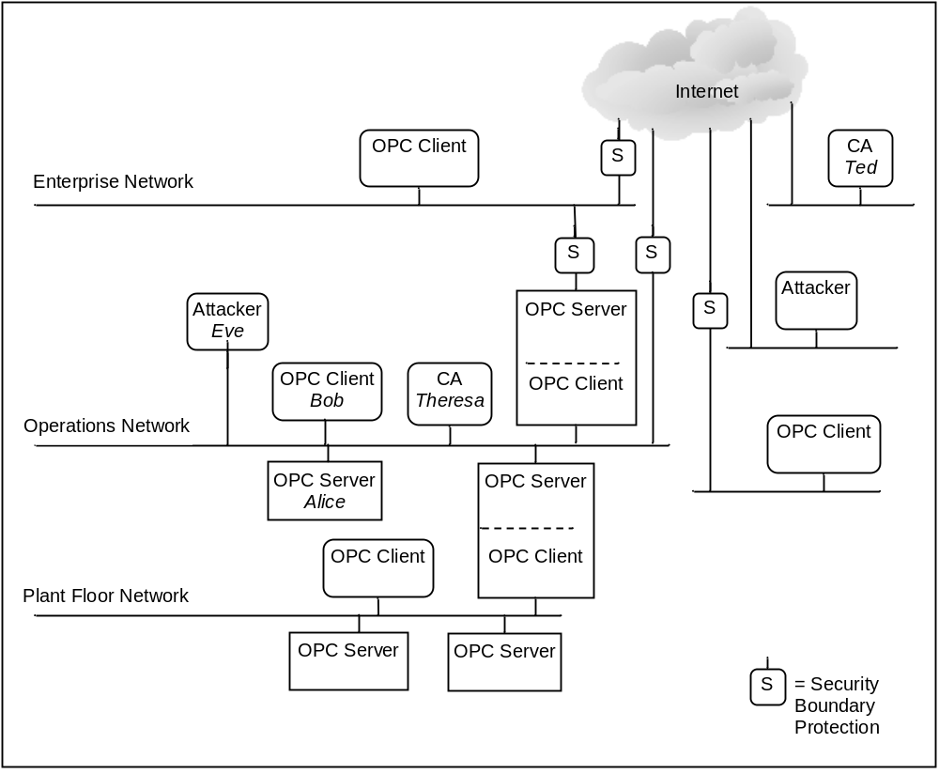
Figure 1 - OPC UA Network Model
OPC UA Applications may run at different places in this wide range of environments. Client and server may communicate within the same host or between hosts within the highly protected control network. Alternatively, OPC UA clients and servers may communicate in the much more open environment over the Internet. The OPC UA activities are protected by whatever security controls the site provides to the parts of the system within which OPC UA Applications run.

Security Objectives

Overview
Fundamentally, information system security reduces the risk of damage from attacks. It does this by identifying the threats to the system, identifying the system’s vulnerabilities to these threats, and providing countermeasures. The countermeasures reduce vulnerabilities directly, counteract threats, or recover from successful attacks.
Industrial automation system security is achieved by meeting a set of objectives. These objectives have been refined through many years of experience in providing security for information systems in general and they remain quite constant despite the ever-changing set of threats to systems. They are described in the following subsections of Section 4.2. Following the sections that describe the OPC UA security architecture and functions, Section 5.2 reconciles these objectives against the OPC UA functions.

Authentication
Entities such as clients, servers, and users should prove their identities. Authentication can be based on something the entity is, has, or knows.

Authorization
The access to read, write, or execute resources should be authorized for only those entities that have a need for that access within the requirements of the system. Authorization can be as coarse-grained as allowing or disallowing a client to call a server or it could be much finer grained, such as allowing specific actions on specific information items by specific users.

Confidentiality
Data must be protected from passive attacks, such as eavesdropping, whether the data is being transmitted, in memory, or being stored. To provide Confidentiality data encryption algorithms are used.

Integrity
Receivers must receive the same information that the sender sent, without the data being changed during transmission.

Auditability
The use of the system must be checked to determine that the security measures are effective. Audits are done rigorously in order to provide evidence of secure operation to stakeholders

Availability
Availability is impaired when the execution of software that needs to run is turned off or when software or the communication system is overwhelmed processing input. Impaired Availability in OPC UA can appear as slowing down of subscription performance or inability to add sessions for example.

Security Threats to OPC UA Systems

Overview
OPC UA provides countermeasures to resist the threats to the security of the information that is communicated. The following subsections of Section 4.3 list the currently known threats to environments in which OPC UA will be deployed. Following the sections that describe the OPC UA security architecture and functions, Section 5.1 reconciles these threats against the OPC UA functions.

Message Flooding
An attacker can send a large volume of messages, or a single message that contains a large number of requests, with the goal of overwhelming the OPC UA server or components on which the OPC UA server may depend for reliable operation such as CPU, TCP/IP stack, Operating System, or the File System. Flooding attacks can be conducted at multiple layers including OPC UA, SOAP, [HTTP] or TCP.
Message flooding attacks can use both well-formed and malformed messages. In the first scenario the attacker could be a malicious person using a legitimate client to flood the server with requests. Two cases exist, one in which the client does not have a session with the server and one in which it does. Message flooding may impair the ability to establish OPC UA sessions, or terminate an existing session. In the second scenario an attacker could use a malicious client that floods an OPC UA server with malformed messages in order to exhaust the server’s resources.
More generally message flooding may impair the ability to communicate with an OPC UA entity and result in denial of service.
Message flooding impacts Availability.
See clause 5.1.2 for the reconciliation of this threat.

Eavesdropping
Eavesdropping is the unauthorized disclosure of sensitive information that might result directly in a critical security breach or be used in follow-on attacks.
If an attacker has compromised the underlying operating system or the network infrastructure, the attacker might record and capture messages. It may be beyond the capability of a client or server to recover from a compromise of the operating system.
Eavesdropping impacts Confidentiality directly and threatens all of the other security objectives indirectly.
See clause 5.1.3 for the reconciliation of this threat.

Message Spoofing
An attacker may forge messages from a client or a server. Spoofing may occur at multiple layers in the in the protocol stack.
By spoofing messages from a client or a server, attackers may perform unauthorized operations and avoid detection of their activities.
Message spoofing impacts Integrity and Authorization.
See clause 5.1.4 for the reconciliation of this threat.

Message Alteration
Network traffic and application layer messages may be captured, modified, and the modified message sent forward to OPC UA clients and servers. Message alteration may allow illegitimate access to a system.
Message alteration impacts Integrity and Authorization.
See clause 5.1.5 for the reconciliation of this threat.

Message Replay
Network traffic and valid application layer messages may be captured and resent to OPC UA clients and servers at a later stage without modification. An attacker could misinform the user or send in improper command such a command to open a valve but at an improper time.
Message replay impacts Authorization.
See clause 5.1.6 for the reconciliation of this threat.

Malformed Messages
An attacker can craft a variety of messages with invalid message structure (malformed XML, SOAP, UA Binary, etc.) or data values and send them to OPC UA clients or servers.
The OPC UA client or server may incorrectly handle certain malformed messages by performing unauthorized operations or processing unnecessary information. It might result in a denial or degradation of service including termination of the application or, in the case of embedded devices, a complete crash.
Malformed messages impact Integrity and Availability.
See clause 5.1.7 for the reconciliation of this threat.

Server Profiling
An attacker tries to deduce the identity, type, software version, or vendor of the server or client in order to apply knowledge about specific vulnerabilities of that product to mount a more intrusive or damaging attack. The attacker might profile the target by sending valid or invalid formatted messages to the target and try to recognize the type of target by the pattern of its normal and error responses.
Server profiling impacts all of the objectives indirectly.
See clause 5.1.8 for the reconciliation of this threat.

Session Hijacking
An attacker may use information (retrieved by sniffing the communication or by guessing) about a running session established between two applications to inject manipulated messages (with valid session information) that allow him to take over the session from the authorized user.
An attacker may gain unauthorized access to data or perform unauthorized operations.
Session hijacking impacts all of the objectives.
See clause 5.1.9 for the reconciliation of this threat.

Rogue Server
An attacker builds a malicious OPC UA server or installs an unauthorized instance of a genuine OPC UA server.
The OPC client may disclose necessary information.
A rogue server impacts all of the security objectives except Integrity.
See clause 5.1.10 for the reconciliation of this threat.

Compromising User Credentials
An attacker obtains user credentials such as usernames, passwords, certificates, or keys by observing them on papers, on screens, or in electronic communications; by cracking them through guessing or the use of automated tools such as password crackers.
An unauthorized user could launch and access the system to obtain all information and make control and data changes that harm plant operation or information. Once compromised credentials are used, subsequent activities may all appear legitimate.
Compromised user credentials impact Authorization and Confidentiality.
See clause 5.1.11 for the reconciliation of this threat.

OPC UA Relationship to Site Security
OPC UA security works within the overall Cyber Security Management System (CSMS) of a site. Sites often have a CSMS that addresses security policy and procedures, personnel, responsibilities, audits, and physical security. A CSMS typically addresses threats that include those that were described in Section 4.3. They also analyze the security risks and determine what security controls the site needs.
Resulting security controls commonly implement a “defence-in-depth” strategy that provides multiple layers of protection and recognizes that no single layer can protect against all attacks. Boundary protections, shown as abstract examples in Figure 1, may include firewalls, intrusion detection and prevention systems, controls on dial-in connections, and controls on media and computers that are brought into the system. Protections in components of the system may include hardened configuration of the operating systems, security patch management, anti-virus programs, and not allowing email in the control network. Standards that may be followed by a site include [NERC CIP] and [IEC 62351] which are referenced in Section 2.
The security requirements of a site CSMS apply to its OPC UA interfaces. That is, the security requirements of the OPC UA interfaces that are deployed at a site are specified by the site, not by the OPC UA specification. OPC UA specifies features that are intended so that conformant client and server products can meet the security requirements that are expected to be made by sites where they will be deployed. Those who are responsible for the security at the site should determine how to meet the site requirements with OPC UA conformant products.
The system owner that installs OPC UA clients or servers should analyze its security risks and provide appropriate mechanisms to mitigate those risks to achieve an acceptable level of security. OPC UA meets the wide variety of security needs that might result from such individual analyses. OPC UA clients and servers are required to be implemented with certain security features, which are available for the system owner’s optional use. Each system owner should be able to tailor a security solution that meets its security and economic requirements using a combination of mechanisms available within the OPC UA specification and external to OPC UA.
The security requirements placed on the OPC UA clients and servers deployed at a site are specified by the site CSMS, not by the OPC UA specification. The OPC UA security specifications, however, are requirements placed upon OPC UA client and server products, and recommendations of how OPC UA should be deployed at a site in order to meet the security requirements that are anticipated to be specified at the site.
OPC UA addresses some threats as described in the section 4.3. The OPC foundation recommends that vendors address the remaining threats, as detailed in section 6. Threats to infrastructure components that might result in the compromise of client and server operating systems are not addressed by OPC UA.

OPC UA Security Architecture
The OPC UA security architecture is a generic solution that allows implementation of the required security features at various places in the OPC UA Application architecture. Depending on the different mappings described in Part 6, the security objectives are addressed at different levels. The OPC UA Security Architecture is structured in an Application Layer and a Communication Layer atop the Transport Layer as shown in Figure 2.
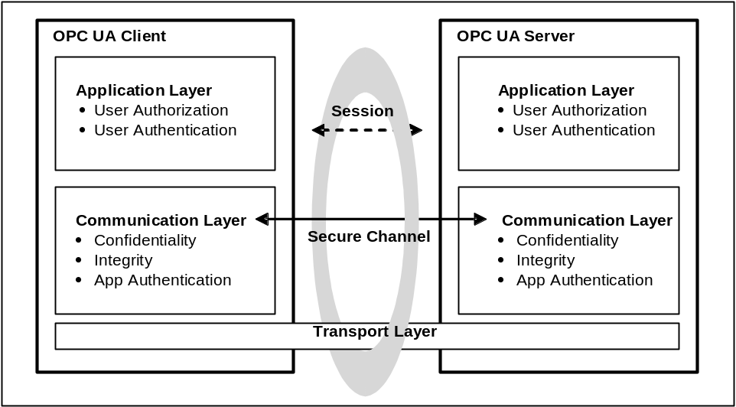
Figure 2 – OPC UA Security Architecture
The routine work of a client application and a server application to transmit plant information, settings, and commands is done in a session in the Application Layer. The Application Layer also manages the security objectives user Authentication and user Authorization. The security objectives that are managed by the Application Layer are addressed by the Session Services that are specified in Part 4. A session in the Application Layer communicates over a Secure Channel that is created in the Communication Layer and relies upon it for secure communication. All of the session data is passed to the Communication Layer for further processing.
Although a session communicates over a Secure Channel and has to be activated before it can be used, the binding of users, sessions, and Secure Channels is flexible.
Impersonation allows the user of the session to change. A session can have a different user than the user that activated the session for the first time, since user credentials are not validated before activating a session.
When a Secure Channel breaks, the session will still be valid to be able to re-establish the Secure Channel otherwise the session closes after its lifetime expires.
The Communication Layer provides security mechanisms to meet Confidentiality, Integrity and application Authentication as security objectives.
One essential mechanism to meet the above mentioned security objectives is to establish a Secure Channel (see Section 4.11) that is used to secure the communication between a client and a server. The Secure Channel provides encryption to maintain Confidentiality, Message Signatures to maintain Integrity and Digital Certificates to provide application Authentication for data that comes from the Application Layer and passes the “secured” data to the Transport Layer. The security mechanisms that are managed by the Communication Layer are provided by the Secure Channel Services that are specified in Part 4.
The security mechanisms provided by the Secure Channel services are implemented by a protocol stack that is chosen for the implementation. Mappings of the services to some of the protocol stack options are specified in Part 6 which details how the functions of the protocol stack are used to meet the OPC UA security objectives.
The Communication Layer can represent an OPC UA protocol stack. OPC UA specifies two alternative stack mappings that can be used as the Communication Layer. These mappings are OPC UA Native mapping and Web Services mapping.
If the OPC UA Native mapping is used, then functionalities for Confidentiality, Integrity, application Authentication, and the Secure Channel are similar to the SSL/TLS specifications, as described in detail in Part 6.
If the Web Services mapping is used, then WS Security, WS Secure Conversation and XML Encryption as well as XML Signature: are used to implement the mechanisms for Confidentiality, Integrity, application Authentication as well as for implementing a Secure Channel. For more specific information, see Part 6.
The Transport Layer handles the transmission, reception and the transport of data that is provided by the Communication Layer.
To survive the loss of the Transport Layer connections (e.g. TCP connections) and resume with another, the implementation of the Communication Layer is responsible to re-establish the Transport Layer connection without interrupting the logical Secure Channel.

Security Policies
Security policies specify which security mechanisms are to be used and are derived from Security Profiles (see section 4.7 for details). Security policies are used by the server to announce what mechanisms it supports and by the client to select one of those available policies to be used for the Secure Channel it wishes to open. The policies specified include the following:
- algorithms for signing and encryption
- algorithm for key derivation
The choice of policy is normally made by the control system administrator, typically when the client and server products are installed.
The announcement of security policies is handled by special discovery services specified in Part 4. More details about the discovery mechanisms and policy announcement strategies can be found in Part 12
If a server serves multiple clients, it maintains separate policy selections for the different clients. This allows a new client to select policies independent of the policy choices that other clients have selected for their Secure Channels.
Since computing power increases over the years specific algorithms that are considered as secure today can become insecure in the future, therefore it makes sense to support different security policies in an OPC UA Application to be able to migrate forward in such a case.
There is also the case that new security policies are composed to support new algorithms that improve the level of security of OPC UA products. The application architecture of OPC UA clients and servers should be designed in a way that it is possible to update or add additional cryptographic algorithms to the application.
Part 7 specifies several policies which are identified by a specific unique URI. To improve interoperability among vendors’ products, server products should implement these policies rather than define their own.

Security Profiles
OPC UA client and server products are certified against profiles that are defined in Part 7. Some of the profiles specify security functions and others specify other functionality that is not related to security. The profiles impose requirements on the certified products but they do not impose requirements on how the products are used. A consistent minimum level of security is required by the various profiles. However, different profiles specify different details, such as which encryption algorithms are required for which OPC UA functions. If a problem is found in one encryption algorithm, then the OPC foundation can define a new profile that is similar, but that specifies a different encryption algorithm that does not have a known problem. Part 7, not this Part 2, is the normative specification of the profiles.
Policies refer to many of the same security choices as profiles, however the policy specifies which of those choices to use in the session. The policy does not specify the range of choices that the product offers like the profile does.
Each security mechanism in OPC UA is provided in client and server products in accordance with the profiles with which the client or server complies. At the site, however, the security mechanisms may be deployed optionally. In this way each individual site has all of the OPC UA security functions available and can choose which of them to use to meet its security objectives.

User Authorization
OPC UA provides a mechanism to exchange user credentials but does not specify how the applications use these credentials. Client and server applications may determine in their own way what data is accessible and what operations are authorized.

User Authentication
User Authentication is provided by the Session Services with which the client passes user credentials to the server as specified in Part 4. The server can authenticate the user with these credentials.
The user who is communicating over a session can be changed using the ActivateSession service in order to meet needs of the application.

Application Authentication
OPC UA uses a concept conveying Application Authentication to allow applications that intend to communicate to identify each other. Each OPC UA Application Instance has a Digital Certificate (Application Instance Certificate) assigned that is exchanged during Secure Channel establishment. The receiver of the Certificate checks whether it trusts it and based on this check it accepts or rejects the request or response message from the sender.
More details on Application Authentication can be found in Part 4.

OPC UA Security Related Services
The OPC UA Security Services are a group of abstract service definitions specified in Part 4 that are used for applying various security mechanisms to communication between OPC UA clients and servers.
The Discovery Service Set (specified in Part 4) defines services used by an OPC UA client to inform itself about the security policies (see Section 4.6) and the Digital Certificates of specific OPC UA servers.
The services of the Secure Channel Service Set (specified in Part 4) are used to establish a Secure Channel which is responsible for securing messages sent between a client and a server. The challenge of the Secure Channel establishment is that it requires the client and the server to securely exchange cryptographic keys and secret information in an insecure environment, therefore a specific Key Exchange Algorithm (similar to SSL Handshake protocol defined in SSL/TLS) is applied by the communication participants:
The OPC UA client retrieves the security policies and Digital Certificates of the OPC UA server by the above mentioned discovery services. These Digital Certificates contain the Public Keys of the OPC UA server.
The OPC UA client sends its Public Key in a Digital Certificate and secret information with the OpenSecureChannel service message to the server. This message is secured by applying Asymmetric Encryption with the server’s Public Key and by generating Asymmetric Signatures with the client’s Private Key. However the Digital Certificate is sent unencrypted so that the receiver can use it to verify the Asymmetric Signature.
The server decrypts the message with its Private Key and verifies the Asymmetric Signature with the client’s Public Key. The secret information of the OPC UA client together with the secret information of the server is used to derive a set of cryptographic keys that are used for securing all further messages. Furthermore all other service messages are secured with Symmetric Encryption and Symmetric Signatures instead of the asymmetric equivalents.
The server sends its secret information in the service response to the client so that the client can derive the same set of cryptographic keys.
Since client and server have the same set of cryptographic keys they can communicate in a secure way with each other.
These derived cryptographic keys are changed periodically so that attackers do not have unlimited time and unrestricted sequences of messages to use to determine what the keys are.

Auditing

General
Clients and servers generate audit records of successful and unsuccessful connection attempts, results of security option negotiations, configuration changes, system changes, and session rejections.
OPC UA provides support for security audit trails through two mechanisms. First, it provides for traceability between client and server audit logs. The client generates an audit log entry for an operation that includes a request. When the client issues a service request, it generates an audit log entry and includes the local identifier of the log entry in the request sent to the server. The server logs requests that it receives and includes the client’s entry id in its audit log entry. In this fashion, if a security-related problem is detected at the server, the associated client audit log entry can be located and examined. OPC UA does not require the audit entries to be written to disk, but it does require that they be available. OPC UA provides the capability for servers to generate event notifications that report auditable events to clients capable of processing and logging them.
Second, OPC UA defines audit parameters to be included in audit records. This promotes consistency across audit logs and in audit events. Part 5: defines the data types for these parameters. Other information models may extend the audit definitions. Part 7 defines profiles, which include the ability to generate audit events and use these parameters, including the client audit record id.
The following clauses illustrate the behaviour of OPC UA servers and clients that support Auditing.

Single client and server
Figure 3 illustrates the simple case of a client communicating with a server.
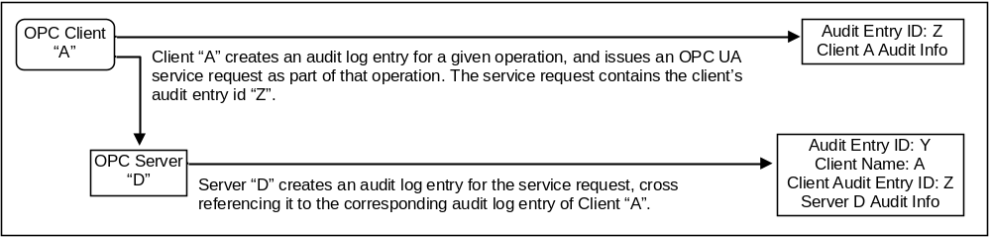
Figure 3 – Simple Servers
In this case, client “A” executes some auditable operation that includes the invocation of an OPC UA service in Server “D”. It writes its own audit log entry, and includes the identifier of that entry in the service request that it submits to the server.
The server receives the request and creates its own audit log entry for it. This entry is identified by its own audit id and contains its own Auditing information. It also includes the name of the client that issued the service request and the client audit entry id received in the request.
Using this information, an auditor can inspect the collection of log entries of the server and relate them back to their associated client entries.

Aggregating server
Figure 4 illustrates the case of a client accessing services from an aggregating server. An aggregating server is a server that provides its services by accessing services of other OPC UA servers, referred to as lower layer-servers.
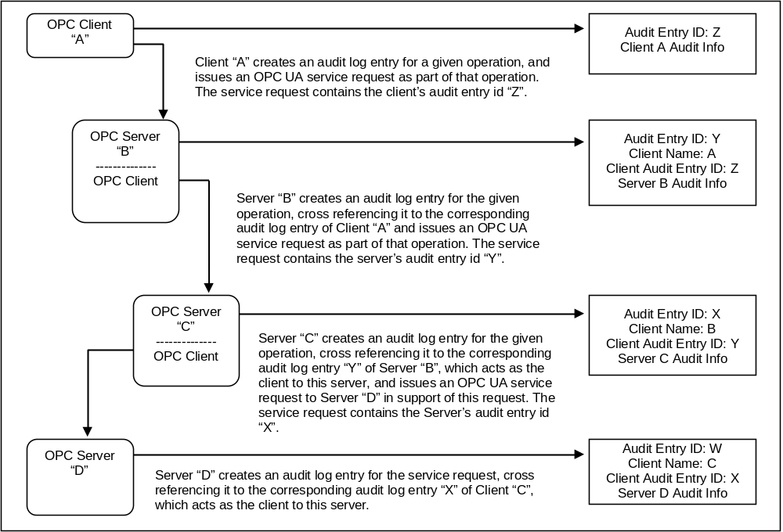
Figure 4 – Aggregating Servers
In this case, each of the servers receives requests and creates its own audit log entry for them. Each entry is identified by its own audit id and contains its own Auditing information. It also includes the name of the client that issued the service request and the client audit entry id received in the request. The server then passes the audit id of the entry it just created to the next server in the chain.
Using this information, an auditor can inspect the server’s log entries and relate them back to their associated client entries.
In most cases the servers will only generate audit events, but these audit events will still contain the same information as the audit log records. In the case of aggregating servers a server would also be required to subscribe for audit events from the servers it is aggregating. In this manner, server “B” would be able to provide all of the audit events to client “A”, including the event generated by server “C” and server “D”

Aggregation through a non-auditing server
Figure 5 illustrates the case of a client accessing services from an aggregating server that does not support Auditing.
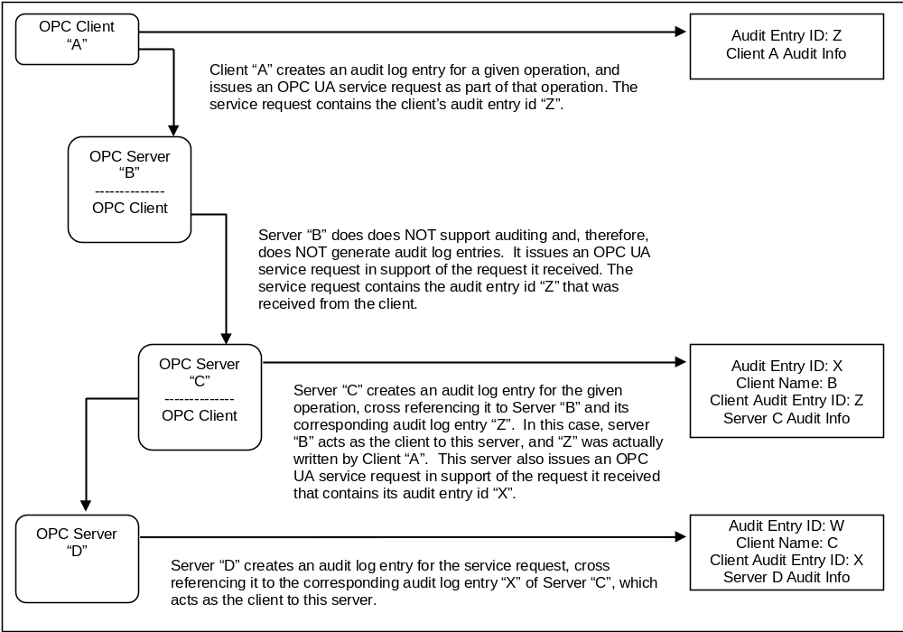
Figure 5 – Aggregation with a Non-Auditing Server
In this case, each of the servers receives their requests and creates their own audit log entry for them, with the exception of server “B”, which does not support Auditing. In this case, server “B” passes the audit id it receives from its client “A” to the next server. This creates the required audit chain. Server “B” is not listed as supporting Auditing. In a case where a server does not support writing audit entries, the entire system may be considered as not supporting Auditing.
In the case of an aggregating server that does not support Auditing, the server would still be required to subscribe for audit events from the servers it is aggregating. In this manner, server “B” would be able to provide all of the audit events to client “A”, including the event generated by server “C” and server “D”, even though it did not generate an audit event.

Aggregating server with service distribution
Figure 6 illustrates the case of a client that submits a service request to an aggregating server, and the aggregating service supports that service by submitting multiple service requests to its underlying servers.
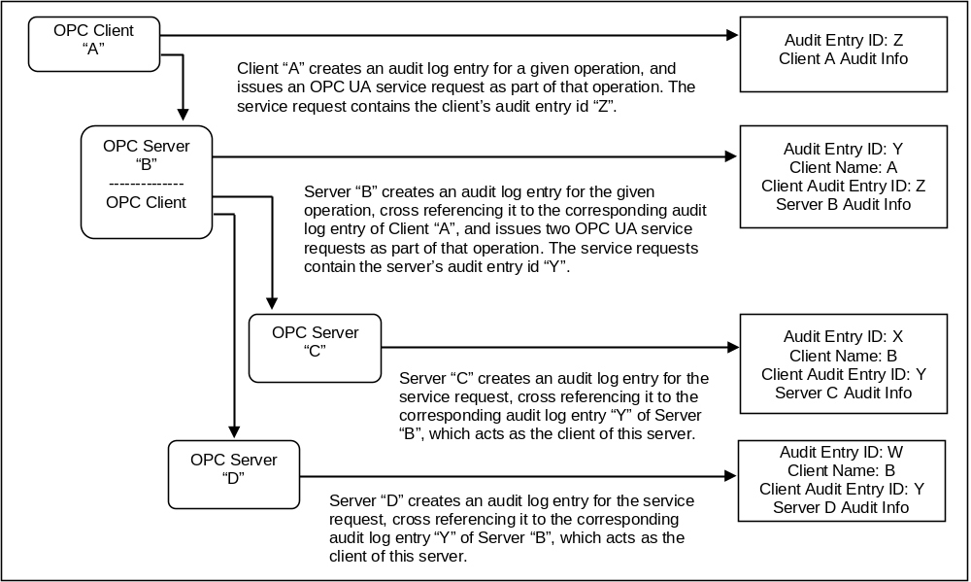
Figure 6 – Aggregate server with Service Distribution
In the case of aggregating servers a server would also be required to subscribe for audit events from the servers it is aggregating. In this manner, server “B” would be able to provide all of the audit events to client “A”, including the event generated by server “C” and server “D”

Security Reconciliation

Reconciliation of Threats with OPC UA Security Mechanisms

Overview
The following subsections of Section 5.1 reconcile the threats that were described in Section 4.3 against the OPC UA functions. Each of the following subsections relates directly to the threat described in its corresponding subsection of Section 4.3.
Compared to the reconciliation with the objectives that will be given in section 5.2, this is a more specific reconciliation that relates OPC UA security functions to specific threats.

Message Flooding
See clause 4.3.2 for a description of this threat.
OPC UA minimizes the loss of Availability caused by message flooding by minimizing the amount of processing done with a message before the message is authenticated. This prevents an attacker from leveraging a small amount of effort to cause the legitimate OPC UA Application to spend a large amount of time responding, thus taking away processing resources from legitimate activities.
GetEndpoints (specified in Part 4) and OpenSecureChannel (specified in Part 4) are the only services that the server handles before the client is recognized. The response to GetEndpoints is only a set of static information so the server does not need to do much processing. The response to OpenSecureChannel consumes significant server resources because of the signature and encryption processing. OPC UA has minimized this processing, but it can not be eliminated.
The server implementation could protect itself from floods of OpenSecureChannel messages in two ways.
First, the server could intentionally delay its processing of OpenSecureChannel requests once it receives a bad one and issuing an alarm would alert plant personnel that an attack is underway that could still be blocking new legitimate OpenSecureChannel calls.
Second, when an OpenSecureChannel request attempts to exceed the server’s specified maximum number of concurrent channels the server replies with an error response without performing the signature and encryption processing. Certified OPC UA servers are required to specify their maximum number of concurrent channels in their product documentation as specified in Part 7.
OPC UA user and client Authentication reduce the risk of a legitimate client being used to mount a flooding attack. See the reconciliation of Authentication in Section 5.2.2.
OPC UA Auditing functionality provides the site with evidence that can help the site discover that flooding attacks are being mounted and find ways to prevent similar future attacks. (See Section 4.12)
OPC UA relies upon the site CSMS to prevent attacks such as message flooding at protocol layers and systems that support OPC UA.

Eavesdropping
See clause 4.3.3 for a description of this threat.
OPC UA provides encryption to protect against eavesdropping as described in Section 5.2.4 - Confidentiality.

Message Spoofing
See clause 4.3.4 for a description of this threat.
As specified in Part 4 and Part 6, OPC UA counters message spoofing threats by the possibility to sign messages. Additionally messages will always contain a valid Session ID, Secure Channel ID, Request ID as well as the correct Sequence Number.

Message Alteration
See clause 4.3.5 for a description of this threat.
OPC UA counters message alteration by the signing of messages that are specified in Part 4. If messages are altered, checking the signature will reveal any changes and allow the recipient to discard the message.

Message Replay
See clause 4.3.6 for a description of this threat.
OPC UA uses Session IDs, Secure Channel IDs, Timestamps, Sequence Numbers and Request IDs for every request and response message. Messages are signed and cannot be changed without detection, therefore it would be very hard to replay a message, such that the message would have a valid Session ID, Secure Channel ID, Timestamp, Sequence Numbers and Request ID. (All of which are specified in Part 4 and Part 6)

Malformed Messages
See clause 4.3.7 for a description of this threat.
Implementations of OPC UA client and server products counter threats of malformed messages by checking that messages have the proper form and that parameters of messages are within their legal range. This is specified in Part 4 and Part 6.

Server Profiling
See clause 4.3.8 for a description of this threat.
OPC UA limits the amount of information that servers provide to clients that have not yet been identified. This information is the response to the GetEndpoints service specified in Part 4.

Session Hijacking
See clause 4.3.9 for a description of this threat.
OPC UA counters session hijacking by assigning a security context (i.e. Secure Channel) with each session as specified in the CreateSession service in Part 4. Hijacking a session would thus first require compromising the security context.

Rogue Server
See clause 4.3.10 for a description of this threat.
OPC UA client applications counter the use of rogue servers by validating server Application Instance Certificates. There would still be the possibility that a rogue server provides a certificate from a certified OPC UA server, but since it does not possess the appropriate Private Key (because this will never be distributed) to decrypt and verify messages secured with the correct Public Key the rogue server would never be able to read and misuse secured data sent by a client.

Compromising User Credentials
See clause 4.3.11 for a description of this threat.
OPC UA protects user credentials sent over the network by encryption as described in Section 5.2.4.
OPC UA depends upon the site CSMS to protect against other attacks to gain user credentials, such as password guessing or social engineering.

Reconciliation of Objectives with OPC UA Security Mechanisms

Overview
The following subsections of Section 5.2 reconcile the objectives that were described in Section 4.2 with the OPC UA functions. Each of the following subsections relates directly to the objective described in its corresponding subsection of Section 4.2.
Compared to the reconciliation against the threats of section 5.1, this reconciliation justifies the completeness of the OPC UA security architecture.

Authentication
OPC UA Applications support Authentication of the entities with which they are communicating as well as providing the necessary Authentication credentials to the other entities.
Application Authentication
As specified in the GetEndpoints and OpenSecureChannel services in Part 4, OPC UA client and server applications identify and authenticate themselves with http://tools.ietf.org/html/rfc3174 X.509 Certificates (see [X509]). Some choices of the Communication Stack require these certificates to represent the machine or user instead of the application.
User Authentication
As described in the OpenSecureChannel service in Part 4, the OPC UA client accepts a User Identity Token from the user and passes it to the OPC UA server. The OPC UA server authenticates the user token. OPC UA Applications accept tokens in any of the following three forms: username/password, an X.509v3 certificate (see [X509]) or a WS-SecurityToken
As specified in the sections of the CreateSession and ActivateSession services in Part 4, if the User Identity Token is a Digital Certificate then this token is validated with a challenge-response process. The server provides a Nonce and signing algorithm as the challenge in its CreateSession response. The client responds to the challenge by signing the server’s Nonce and providing it as an argument in its subsequent ActivateSession call.

Authorization
OPC UA does not specify how user or client Authorization is to be provided. OPC UA Applications that are part of a larger industrial automation product may manage Authorizations consistent with the Authorization management of that product. Identification and Authentication of users is specified in OPC UA so that client and server applications can recognize the user in order to determine the Authorizations of the user.
OPC UA servers respond with the Bad_UserAccessDenied error code to indicate an Authorization or Authentication error as specified in the status codes section of Part 4.

Confidentiality
OPC UA uses Symmetric and Asymmetric Encryption to protect Confidentiality as a security objective. Thereby Asymmetric Encryption is used for key agreement and Symmetric Encryption for securing all other messages sent between OPC UA applications. Encryption mechanisms are specified in [UA Part 6].
OPC UA relies upon the site CSMS to protect Confidentiality on the network and system infrastructure. OPC UA relies upon the PKI to manage keys used for Symmetric and Asymmetric Encryption.

Integrity
OPC UA uses Symmetric and Asymmetric Signatures to address Integrity as a security objective. The Asymmetric Signatures are used in the key agreement phase during the Secure Channel establishment. The Symmetric Signatures are applied to all other messages.
OPC UA relies upon the site CSMS to protect Integrity on the network and system infrastructure. OPC UA relies upon the PKI to manage keys used for Symmetric and Asymmetric Signatures.

Auditability
As specified in the UA Auditing section of Part 4, OPC UA supports audit logging by providing traceability of activities through the log entries of the multiple clients and servers that initiate, forward, and handle the activity. OPC UA depends upon OPC UA Application products to provide an effective audit logging scheme or an efficient manner of collecting the audit events of all nodes. This scheme may be part of a larger industrial automation product of which the OPC UA Applications are a part.

Availability
OPC UA minimizes the impact of message flooding as described in Section 5.1.2.
Some attacks on Availability involve opening more sessions than a server can handle thereby causing the server to fail or operate poorly. Servers reject sessions that exceed their specified maximum number.

Implementation considerations
This section provides guidance to vendors that implement OPC UA Applications. Since many of the countermeasures required to address the threats described above fall outside the scope of the OPC UA specification, the advice in this section suggests how some of those countermeasures should be provided.
For each of the following areas, this section defines the problem space, identifies consequences if appropriate countermeasures are not implemented and recommends best practices.

Appropriate Timeouts:
Timeouts, the time that the implementation must wait (usually for an event such as message arrival), play a very significant role in influencing the security of an implementation. Potential consequences include
- Denial of service: Denial of service conditions may exist when a client does not reset a session, if the timeouts are very large.
- Resource consumption: When a client is idle for long periods of time, the server must keep the client information for that period, leading to resource exhaustion.
The implementer should use reasonable timeouts for each connection stage.

Strict Message Processing
The specifications often specify the format of the right messages and are silent on what the implementation should do for messages that deviate from the specification. Typically, the implementations continue to parse such packets, leading to vulnerabilities.
- The implementer should do strict checking of the message format and should either drop the packets or send an error message as described below.
- Error handling uses the error code, defined in Part 4, which most precisely fits the condition.

Random Number Generation
Random numbers that meet security needs can be generated by suitable functions that are provided by cryptography libraries. Common random function such as using rand() provided by the CRT doesn’t generate enough entropy. As an alternative, implementers could use the random number generator provided by the MS Windows Crypto library (WinCrypt library) or by OpenSSL.

Special and Reserved Packets
The implementation must understand and correctly interpret any message types that are reserved as special (such as broadcast and multicast addresses in IP specification). Failing to understand and interpret those special packets may lead to vulnerabilities.

Rate Limiting and Flow Control
OPC-UA does not provide rate control mechanisms, however an implementation can incorporate rate control.

